Step 1,
Selected the job to add the FTP Upload.
Only option I could see was Cloud Transfer Upload File(s)

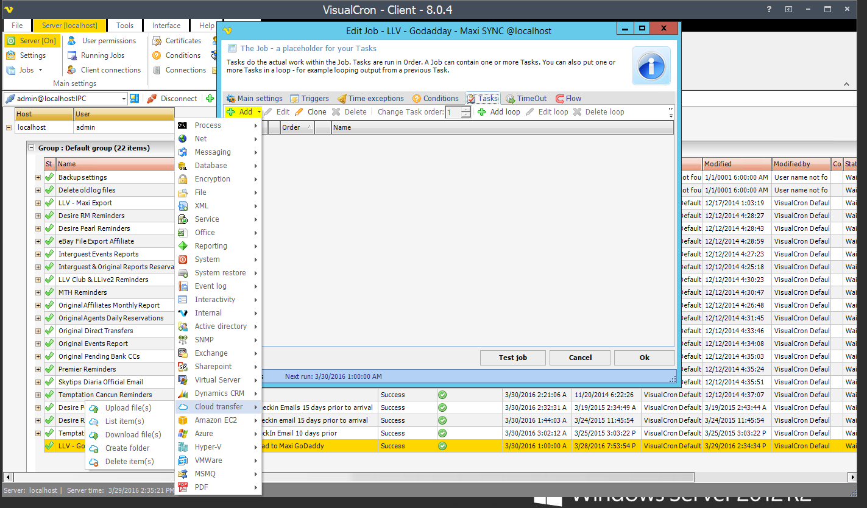

Step 2
Add Task – Upload File(s)
You will notice the first option (Main settings) is to choose a connection, the only option is to click that tools (cogs) icon on far right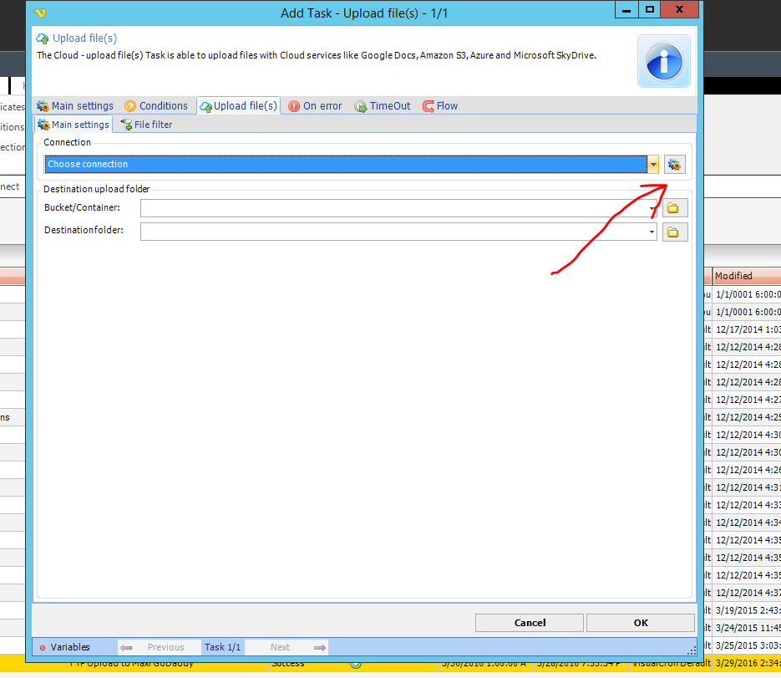

Step 3
Clicking the tools icon shows new window where you need to select show all protocols to list the connection I setup.

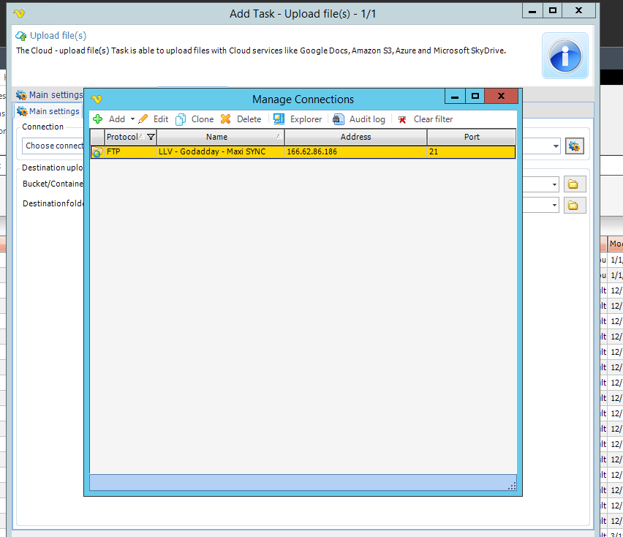

Step 4
If I select the Protocol by double clicking it just lets me edit that connection, and clicking OK does not actually select it in the Choose connection area of Main settings screen.

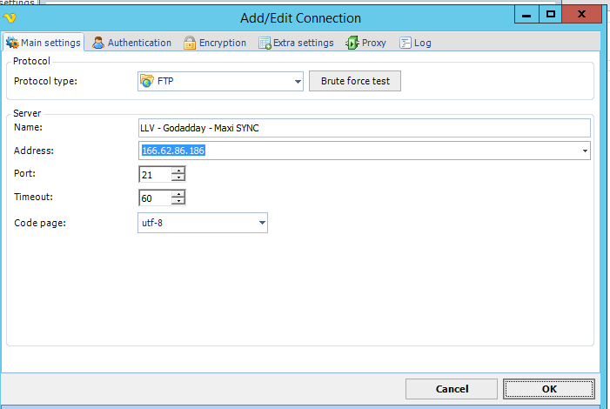
OK?

