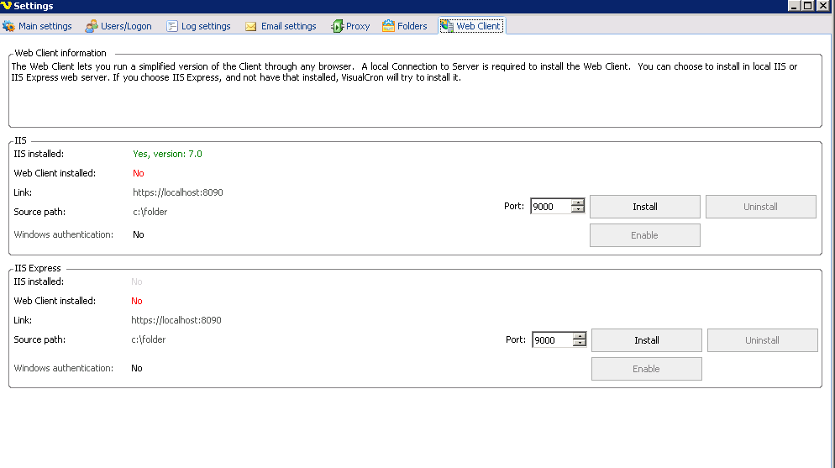
No WebClient installed. I press Install button ..
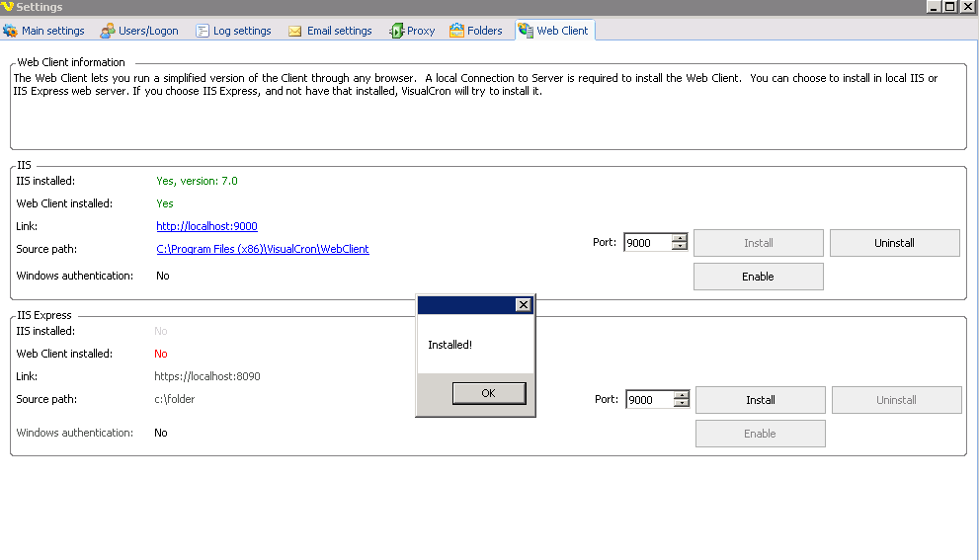

Message about succesful installation. I apply settings and close the window. Open the window again and click on the link to http://localhost:9000
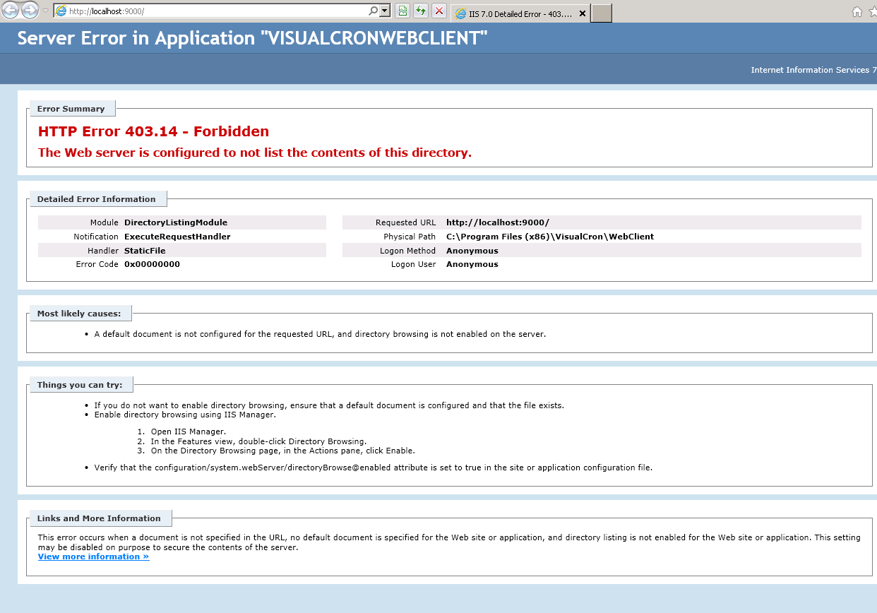

In the IIS Server

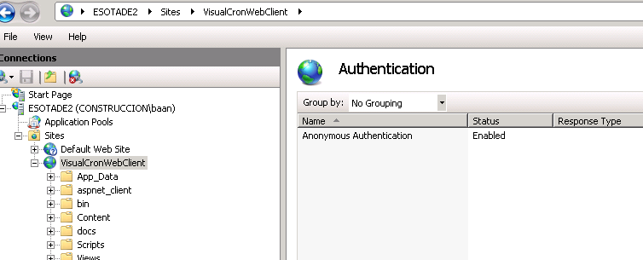

By default:
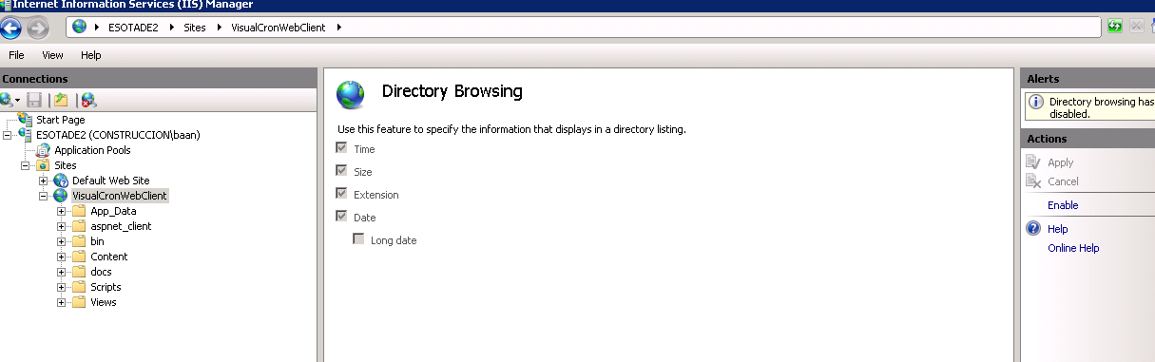

If I enable the directory browsing:

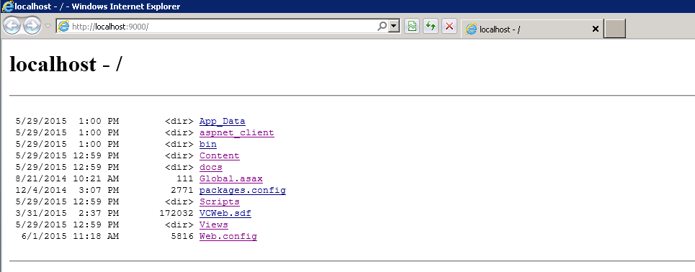

The default document setting:

