I would like to create a scheduler to execute the exe from the local directory.
My main setting for JOB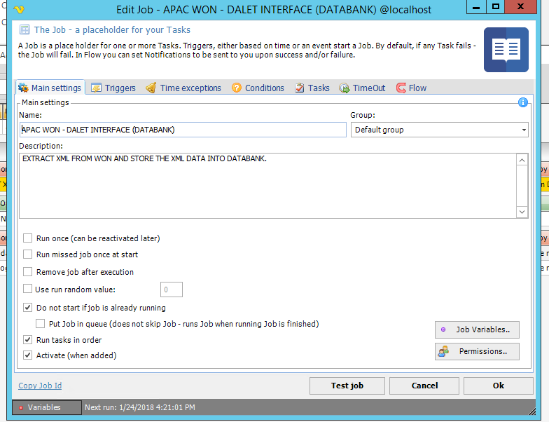
The Triggering setting
By event.

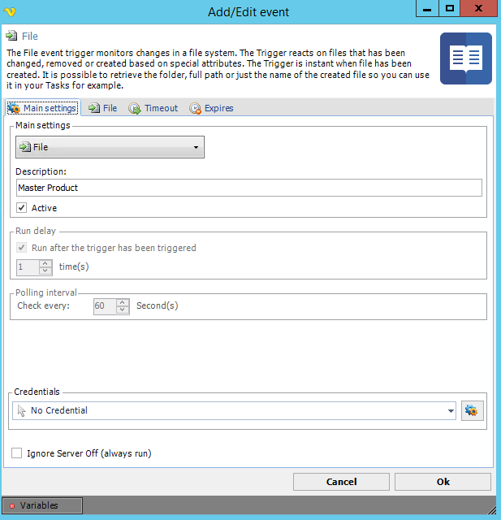

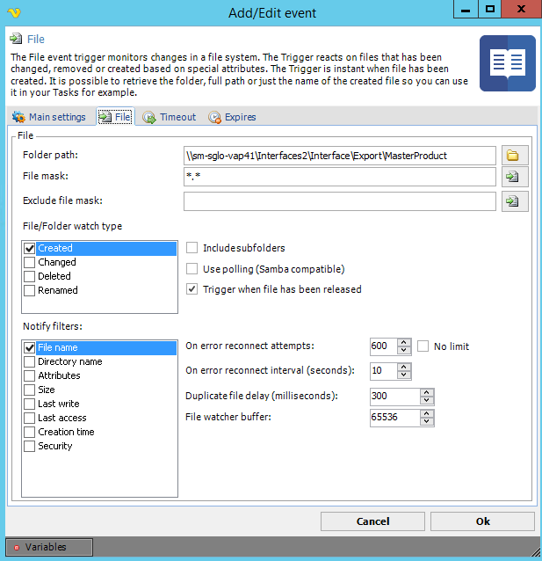

After I clicked OK the Active state under Active column will not be tick off. The trigger is not executed at all event changes.

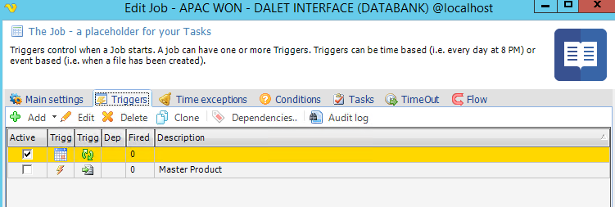

Task Setting
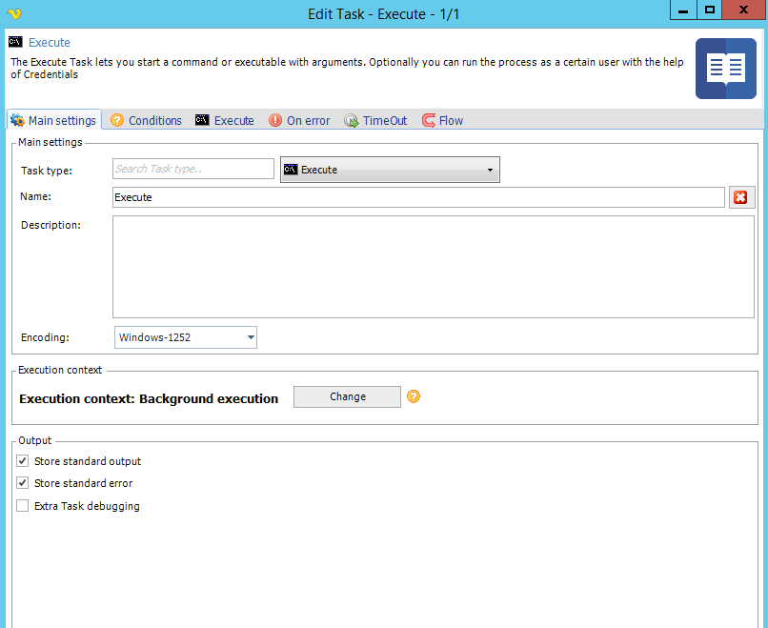

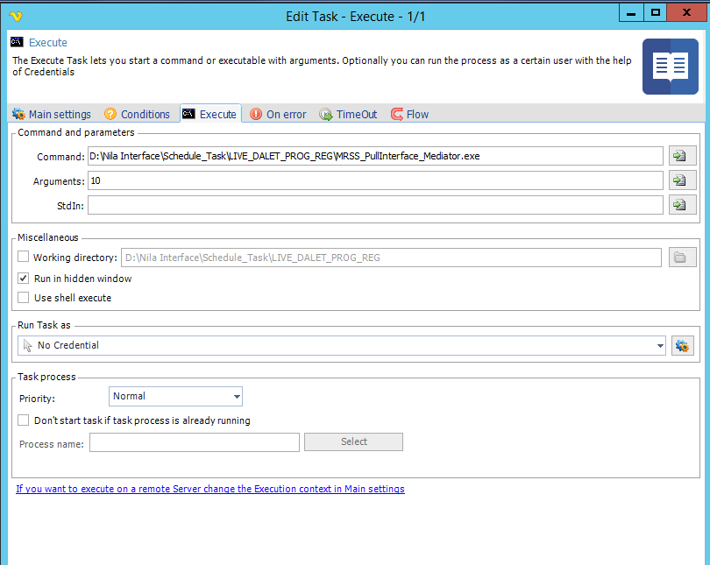

Result : Execute with Errors but it works if I direct trigger from the folder and Window Task scheduler.
