On 2014-10-09 12:25, Lee Burns wrote:

Henrik

This bug is now fixed and I can use the Radio buttons as specified but……..

I have uncovered another 3 issues in the popup formatting.

1) If I have too many inputs, they do not fit on the pop up:

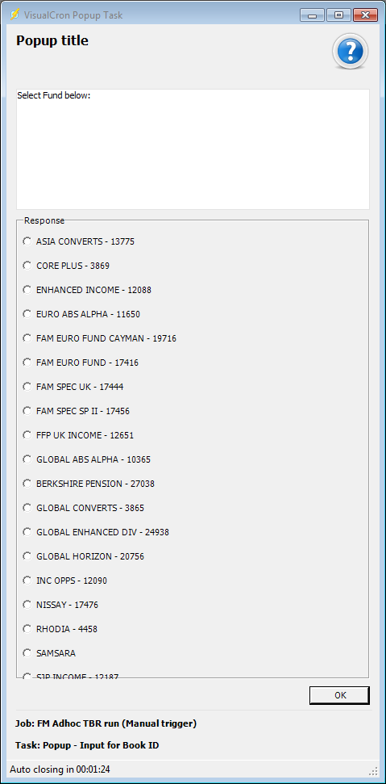
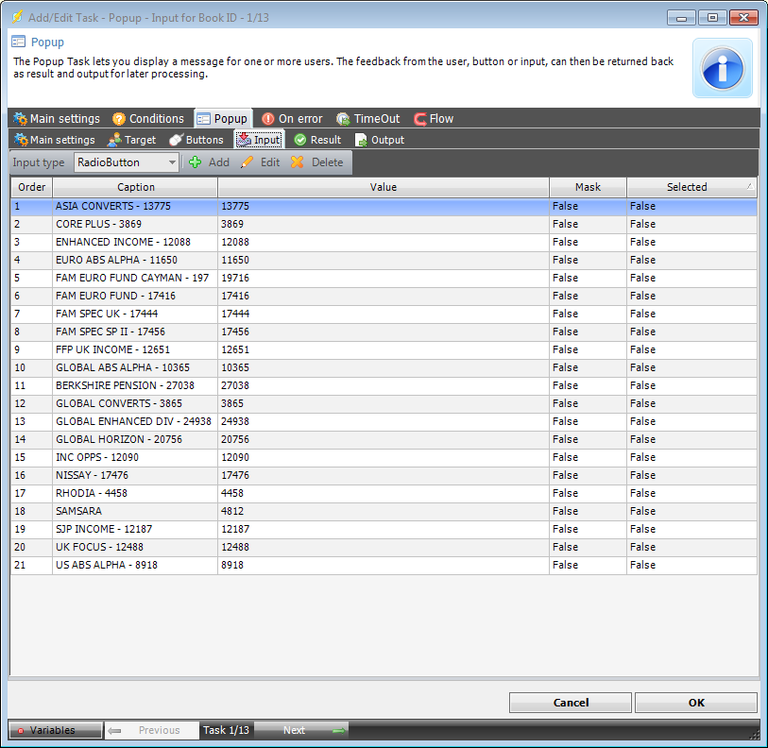

I can resize the pop up window, but if we could take out the space between the radio buttons that would help for a simple solution.

2) If we could have some options for the Pop up Message box. E.g. resizing options and option to disable/enable the pop up message completely? (These would help with point 1 also.)
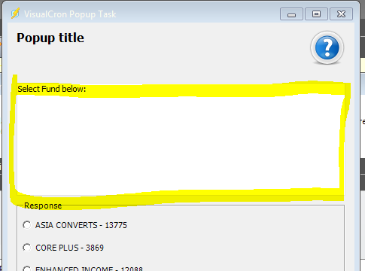

3) Not a major one, but there is no way to re-order your input list.

E.g. If I have created a list of inputs and wanted to put them in alpha order:
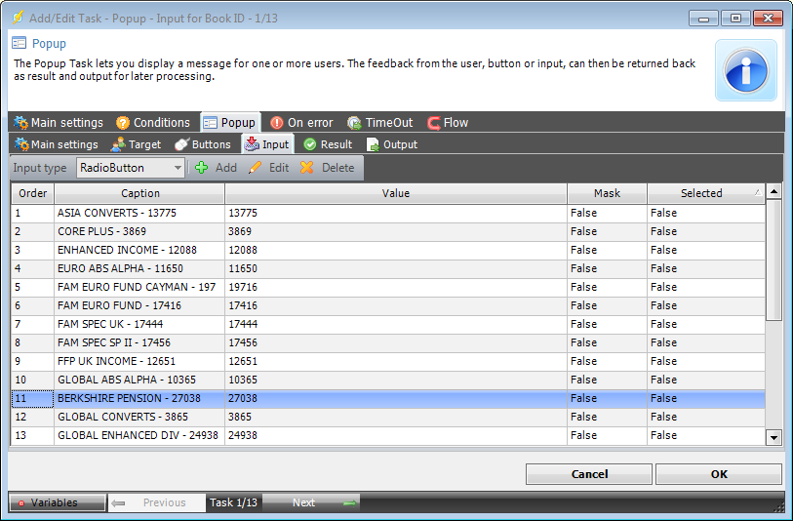

In this case I would have to delete and re-add the Inputs. Time consuming but not a major issue.

Shall I raise a feature request for this on the forum?

Thanks

Lee

