- Create a sql task. In the sql tab write the following code (just as a simple example)

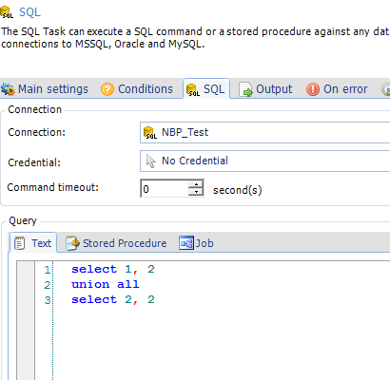

In the output tab choose the field separator you want, say semicolon:
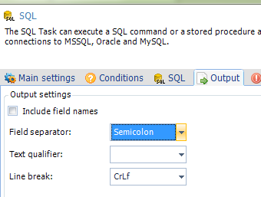

- Let’s create a silly stored procedure that takes an int as parameter and returns the parameter + 1:

USE NBP_Test
GO

CREATE PROCEDURE p_test (@input1 INT)
AS
BEGIN
SET NOCOUNT ON;

SELECT @input1 + 1;
END;

- Create a new sql task. This task will loop over the result of the previous set, and call the procedure. For now, just create it and click ok.
Double-click in the loop column
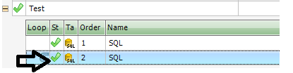
Give it a name if you wish, and go to the loop settings tab.
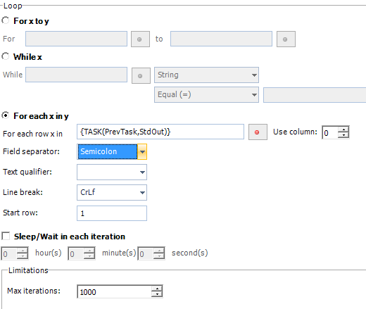
Make sure you have semicolon, and I will choose column 0 (ie first column). Click OK to exit

- Double click this sql taks again to get to the main settings. Choose the sql tab and find the procedure you created:
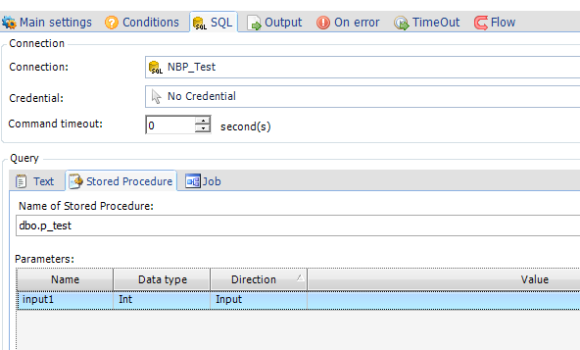

We need to pass a parameter value , so double-click value
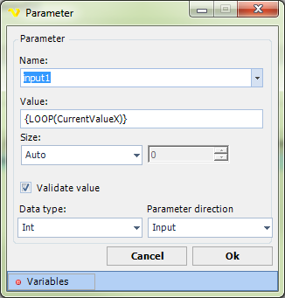
The value passed will be the current loop value. In our case column 1. Make sure you uncheck validate value, as VC cannot check if this value is a proper int.

Run the job, and it should work.
Next , what if you needed both values as parameters? Start by rewriting the procedure:
USE NBP_Test
GO

ALTER PROCEDURE p_test (@input1 INT, @input2 INT)
AS
BEGIN
SET NOCOUNT ON;

SELECT (@input1 + 15) * @input2;
END;

Now we need to ‘trick’ VC a bit. Remember the query returns a semicolon separated string? Leave it like that, but go to the loop and change the field separator there to for example tab
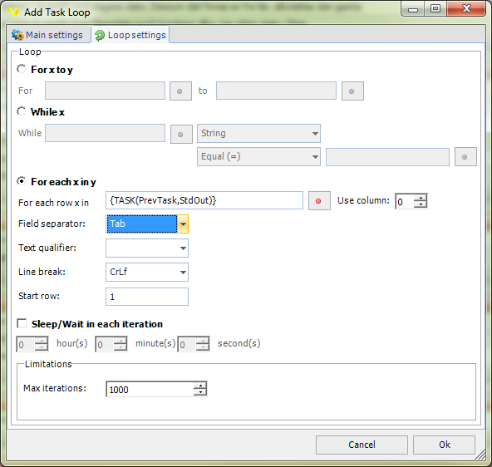

Now the query still returns 1;2 on the first iteration, but we basically ignore the separator (that’s why I chose tab) and ask for the entire line.
Go back to the procedure, refresh the parameters. You should have to parameters now:
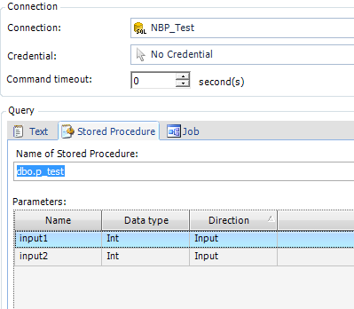

In the first iteration we have the result 1;2 as mentioned. We need to split this and separate into two parameters. Go to variables, functions, and ‘Get column by row, column and column separator’. Parameters should look like this now:

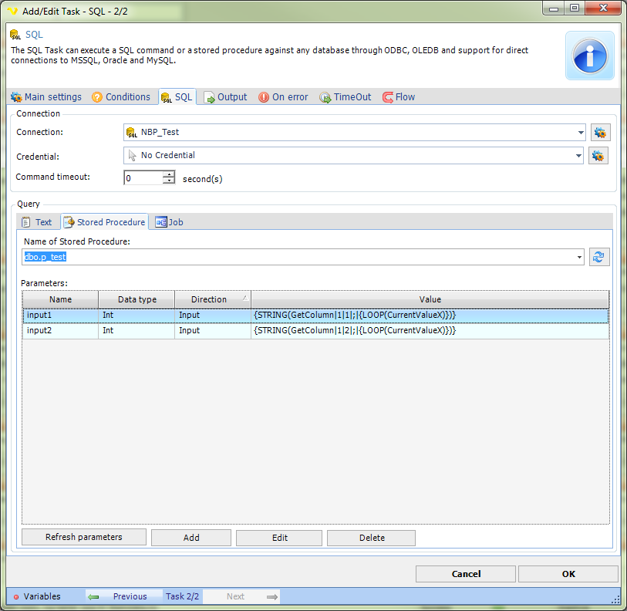

Input1 is the first row and the first column from the current row in the loop, which is as semicolon separated string.
Input2 is the first row and the second column from the current row in the loop, which is as semicolon separated string.

