Sync Files Task – Test Results

Sync Settings

Source
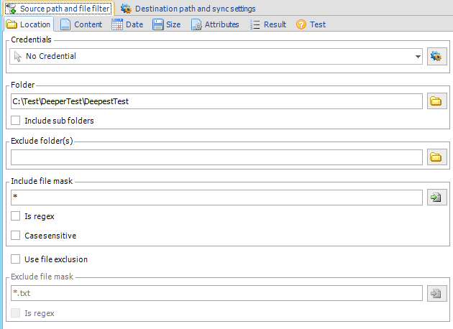

Destination
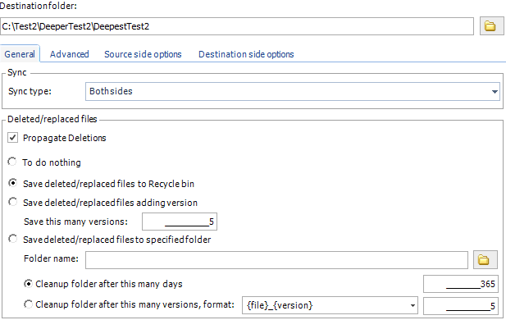

Other Settings
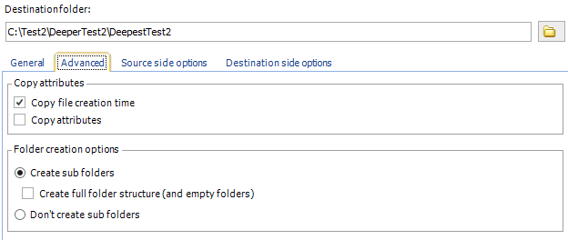
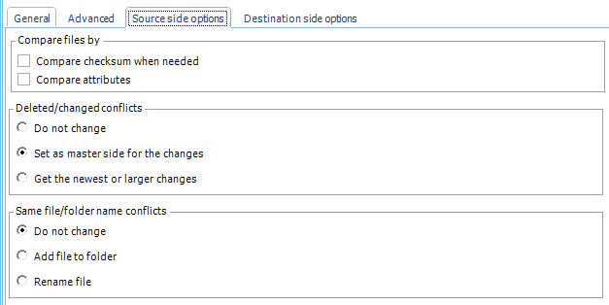
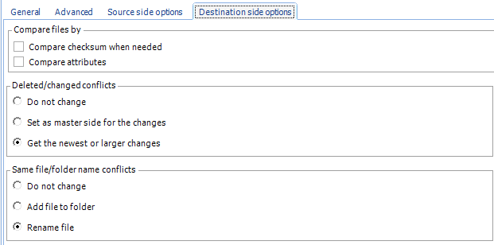

Tests

Files Exist in Source but not Destination
Files were copied to destination.

File Missing From Source that Does Exist in Destination
File was deleted from destination.

File Renamed in Source
File was renamed in destination.

File Renamed Back to Original Name in Source
Copy of the file with both names now exists in both folders.

File Deleted From Destination
File re-copied from source.

File Deleted From Source Again
File copied back to source.

