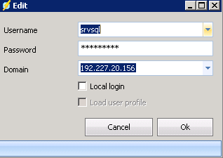
That’s the IP of the SQL Server.
Srvsql is a local Admin, the user who starts the SQL services and has full access to the integration services.

This is the error:

Unhandled error occured: Microsoft.SqlServer.Dts.Runtime.DtsRuntimeException: The LoadFromSQLServer method has encountered OLE DB error code 0x80040E4D (Login failed for user 'srvsql'.). The SQL statement that was issued has failed.
---> System.Runtime.InteropServices.COMException (0xC0014062): The LoadFromSQLServer method has encountered OLE DB error code 0x80040E4D (Login failed for user 'srvsql'.). The SQL statement that was issued has failed.

at Microsoft.SqlServer.Dts.Runtime.Wrapper.ApplicationClass.LoadFromSQLServer(String bstrPackagePath, String bstrServerName, String bstrServerUserName, String bstrServerPassword, Boolean bLoadNeutral, IDTSEvents100 pEvents)
at Microsoft.SqlServer.Dts.Runtime.Application.LoadFromSqlServer(String packagePath, String serverName, String serverUserName, String serverPassword, IDTSEvents events)
--- End of inner exception stack trace ---
at Microsoft.SqlServer.Dts.Runtime.Application.LoadFromSqlServer(String packagePath, String serverName, String serverUserName, String serverPassword, IDTSEvents events)
at SSISExecute2008.SSIS2008.ExecutePackage(TaskSSISInfoClass task)
at aiQcxUIZ97rbBYdhK9.axW3kZO5fk3EDtF4IW.RucuGcrpu(String[] )
Exception in Task: Non zero exit code

