**Visualcron**

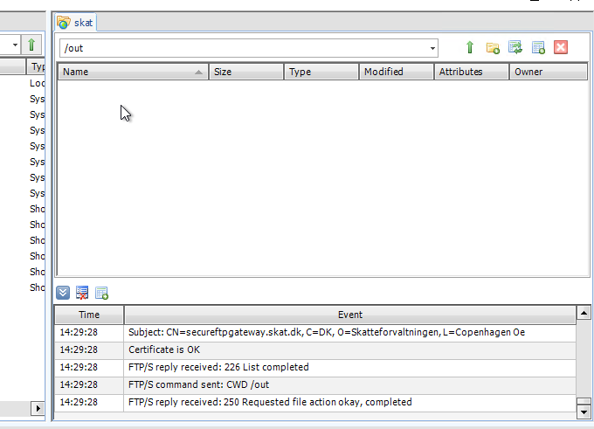

14:30:29: FTP/S command sent: PWD

14:30:29: FTP/S reply received: 257 "/out" is current directory.

14:30:29: FTP/S command sent: CWD /out

14:30:29: FTP/S reply received: 250 Requested file action okay, completed

14:30:29: FTP/S command sent: TYPE A

14:30:29: FTP/S reply received: 200 Command okay

14:30:29: FTP/S command sent: PASV

14:30:29: FTP/S reply received: 227 Entering passive mode (195,85,251,102,136,248).

14:30:29: FTP/S command sent: LIST

14:30:31: FTP/S reply received: 125 List started

14:30:31: Certificate received

14:30:31: Issuer: CN=GlobalSign, C=, O=GlobalSign, L=

14:30:31: Subject: CN=GlobalSign, C=, O=GlobalSign, L=

14:30:31: Certificate is OK

14:30:31: Certificate received

14:30:31: Issuer: CN=GlobalSign, C=, O=GlobalSign, L=

14:30:31: Subject: CN=GlobalSign RSA OV SSL CA 2018, C=BE, O=GlobalSign nv-sa, L=

14:30:31: Certificate is OK

14:30:31: Certificate received

14:30:31: Issuer: CN=GlobalSign RSA OV SSL CA 2018, C=BE, O=GlobalSign nv-sa, L=

14:30:31: Subject: CN=secureftpgateway.skat.dk, C=DK, O=Skatteforvaltningen, L=Copenhagen Oe

14:30:31: Certificate is OK

14:30:32: FTP/S reply received: 226 List completed

14:30:32: FTP/S command sent: CWD /out

14:30:32: FTP/S reply received: 250 Requested file action okay, completed

**FTP Core LE**

Same folder, but the xml files are visual here:

